Research_Team_2_Progress_Update_Report_Knight

Michael Knight

11/21/2021

## Importing and Formatting the data

## Rename The Columns We will be Observing

Define our variables (in a table)

## var_names  
## 1 News_Preference  
## 2 Trust_in_Others  
## 3 Trust_in_social_media_news  
## 4 Fact_Check  
## 5 How_often_social_media_for_news  
## 6 Trust_in_natl_news_orgs  
## questions_asked  
## 1 Which of the following would you say you prefer for getting news?  
## 2 Generally speaking, would you say that most people can be trusted or that you can't be too careful in dealing with people?  
## 3 How much, if at all, do you trust the information you get from Social networking sites, such as Facebook and Twitter?  
## 4 When you are online and come across information in a news story that you think is inaccurate, how often do you take it upon yourself to figure out whether it is accurate?  
## 5 How often do you get news from a social networking site?  
## 6 How much, if at all, do you trust the information you get from National news organizations?  
## answers  
## 1 TV, Radio, Newspaper, Social Media, News Site/App  
## 2 Can't be too careful (0), Most people can be trusted (1)  
## 3 Not at all (0), Not too much (1), Some (2), A lot (3)  
## 4 Never (0), Hardly ever (1), Sometimes (2), Often (3)  
## 5 Never (0), Hardly ever (1), Sometimes (2), Often (3)  
## 6 Not at all (0), Not too much (1), Some (2), A lot (3)

# The hypotheses for this research are:

## Hypothesis 1. People who get their news from social media feel that most people in general cannot be trusted.

## Hypothesis 2: People who get their news from social media feel that most national news orgs cannot be trusted.

### Hypothesis 1 pt 2: News_Preference vs. Trust_in_Others

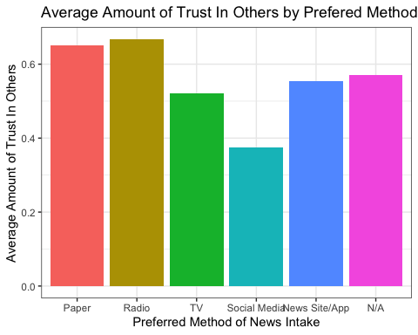

Graph interpretation: The group with the least average amount of trust in others (measured from 0 to 1, with 0 being “Can’t be too careful” and 1 being “Most people can be trusted”) was the group whose Preferred Method of Intake was Social Media. The survey questions here were Q: Which of the following would you say you prefer for getting news? and Q: Generally speaking, would you say that most people can be trusted or that you can’t be too careful in dealing with people?

### Hypothesis 1 pt 2: How_often_social_media_for_news vs. Trust_in_Others

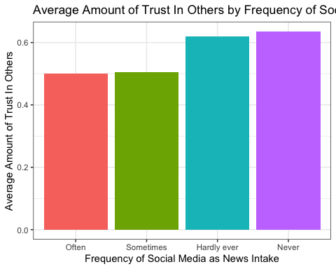

Graph interpretation: The group with the least average amount of trust in others (measured from 0 to 1, with 0 being “Can’t be too careful” and 1 being “Most people can be trusted”) was the group whose Frequency of Social Media Intake was the most frequent. In fact, it is easily observable that there is a direct linear correlation with Frequency of Social Media as News Intake and Average Amount of Trust In Others. The survey questions here were Q: Which of the following would you say you prefer for getting news? and Q: Generally speaking, would you say that most people can be trusted or that you can’t be too careful in dealing with people?

## Hypothesis 2: People who get their news from social media feel that most national news orgs cannot be trusted.

### Hypothesis 2 pt 1: News_Preference vs. Trust_in_natl_news_orgs

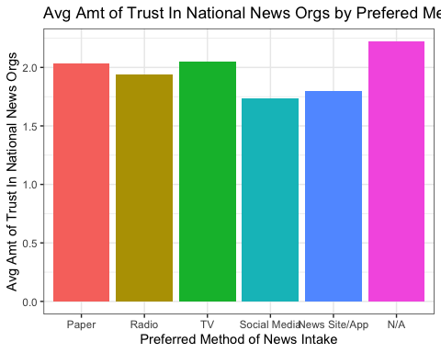

Graph interpretation: The group with the least average amount of trust in National News Organizations (measured from 0 to 3, with 0 being “Not at all”, 1 being “Not too much”, 2 being “Some”, and 3 being “A lot”) was the group whose Preferred Method of Intake was Social Media. The survey questions here were Q: Which of the following would you say you prefer for getting news? and Q: How much, if at all, do you trust the information you get from National news organizations?

### Hypothesis 2 pt 2

How_often_social_media_for_news vs. Trust_in_natl_news_orgs 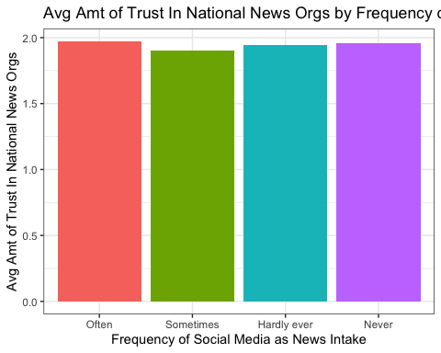

Graph interpretation: The group with the least average amount of trust in National News Organizations (measured from 0 to 3, with 0 being “Not at all”, 1 being “Not too much”, 2 being “Some”, and 3 being “A lot”) was the group whose Frequency of Social Media Intake was the most frequent. The survey questions here were Q: Which of the following would you say you prefer for getting news? and Q: How much, if at all, do you trust the information you get from National news organizations?

### Hypothesis 3

People who do not trust the news they see online are more likely to fact check. Trust_in_social_media_news vs. Fact_Check 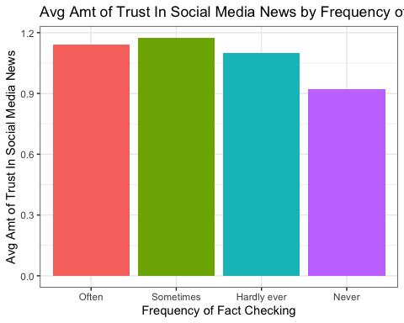

Contradicts our initial hypothesis: for the most part, the more people trusted social media news, the more they fact checked

Graph interpretation: The groups with higheraverage amounts of trust in social media news (measured from 0 to 3, with 0 being “Not at all”, 1 being “Not too much”, 2 being “Some”, and 3 being “A lot”) tended to more Frequently Fact Check their news. The survey questions here were Q: When you are online and come across information in a news story that you think is inaccurate, how often do you take it upon yourself to figure out whether it is accurate? and Q: How much, if at all, do you trust the information you get from Social media news?